BS(CS) FINAL PROJECT
Software Requirements Specification

FinSync: Universal Money Management App


Product Owner

Engr. Sajid Saleem

Presented by:
Group ID: S26CS033

Student Reg# Student Name

L1S22BSCS0005 Muhammad Hassan

L1S23BSCS0216 Abdul Kareem Butt

L1S23BSCS0191 Muhammad Faizan

Faculty of Information Technology & Computer Science
University of Central Punjab

Software Requirements Specification
Version: 1.0

Product Owner:
Engr. Sajid Saleem

Scrum Master
Muhammad Hassan Group S26CS033

Team

Member Name | Roles
Muhammad Hassan | Scrum Master, AI/NLP Integration, Backend Development
Abdul Kareem Butt | Frontend Development, UI/UX Design, Mobile App Dev
Muhammad Faizan | Database Management, OCR Implementation, QA Testing

Table of Contents
Table of Contents i
Revision History & Sprint Log ii
Previous Phases Feedback ii
Abstract 1
- Introduction and Background 2
  - Product Vision & Problem Context 2
  - Stakeholders Identification 2
- Agile Framework Setup 3
  - Epics For the Project 3
  - Product Backlog 4
  - User Stories 4
  - Story Points & Estimation 6
  - Sprint Planning & Sprint Backlog 8
- Functional Requirements 10
  - Use Case Diagram 10
- Non-functional Requirements 11
  - Reliability 14
  - Performance 14
  - Use-ability 14
  - Other Non-functional Requirements 14
- Scrum Activities Plan 14
  - Kanban Board / Task Tracking 15
  - Acceptance Criteria 15
  - Release Criteria 18
  - Burndown Chart & Progress Tracking 18
  - Backlog Refinement Plan 19
- Risk Analysis 20
- References 21
Appendix A: Glossary 22
Appendix B: IV & V Report 23

Revision History & Sprint Log

Version | Sprint | Date | Changes | Owner

Previous Phases Feedback

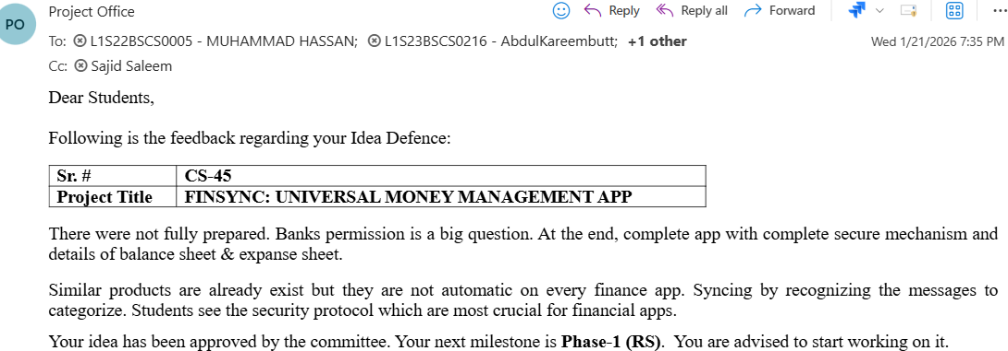

Abstract
Managing personal finances has become increasingly complex for individuals who rely on multiple bank accounts, digital wallets, and payment channels. In Pakistan, financial information is scattered across SMS alerts, WhatsApp receipts, banking applications, and manual records. This fragmentation prevents users from obtaining a clear, consolidated overview of their spending patterns, recurring expenses, or cash flow. As a result, individuals struggle with budgeting, tracking expenses, and making informed financial decisions. The lack of an automated, centralized system forces users to depend on manual entry methods, which are inefficient, time-consuming, and prone to oversight.

FinSync – Universal Money Management App is a unified financial management platform that automatically consolidates transactions, categorizes expenses, and delivers personalized analytical insights. By combining data from unstructured text (SMS/WhatsApp) and applying machine learning for categorization, the system empowers users to gain complete control over their financial health. The project addresses a genuine, large-scale challenge with strong societal relevance and robust technical depth, aiming to improve personal financial awareness and promote responsible spending habits in Pakistan.

Introduction and Background

Product Vision & Problem Context
Real Time Problem Description: In Pakistan’s rapidly evolving digital financial landscape, users receive transaction information through various channels like SMS alerts, WhatsApp receipts, and mobile banking apps. However, these services operate in isolation, leaving users with fragmented financial data. This makes it difficult to understand expenditure patterns, track monthly outgoings, or form healthy budgeting habits. The absence of open banking APIs in Pakistan further intensifies this problem, as there is no unified platform to aggregate this data automatically.

Target Users:
    - Frequent mobile banking and digital wallet users (JazzCash, EasyPaisa, etc.).
    - Students and hostilities manage tight budgets.
    - Freelancers and salaried professionals with multiple income/expense streams.

Objectives of the System:
    - To provide a unified dashboard for all bank and wallet balances.
    - To automate transaction parsing from SMS and WhatsApp with high accuracy.
    - To offer AI-driven financial coaching and predictive spending insights.

User Research:
We conducted interviews with 10 potential users, including students and professionals. The research revealed that 90% of participants rely on SMS alerts for transaction records but find it overwhelming to track them manually across different apps. Observation of current processes showed that users often miss small expenses, leading to budget overruns.
Expected Benefits:
    - Consolidated financial view reducing manual tracking effort by 90%.
    - Improved financial literacy and awareness through AI insights.
    - Better budgeting discipline and increased savings for users.

Stakeholders Identification

Stakeholder Name | Role | Their Expectations
End Users | Primary Users | Automated tracking, secure data handling, and intuitive UI.
Supervisor | Product Owner | Technical robustness, adherence to academic standards, and timely  delivery.
Development Team | Developers/QA | Clear requirements, efficient tools, and successful project completion.
Financial Institutions | Data Sources | (Indirect) Accurate  representation of transaction data.

Agile Framework Setup
Our team will follow the Scrum framework to ensure iterative development and continuous improvement over the one-year duration of the Final Year Project (FYP). The project is divided into two main phases: the first semester focuses on comprehensive documentation, requirements gathering, and system design, while the second semester is dedicated to implementation, testing, and deployment.

Team Roles:
- Product Owner: Prof. Mr. Sajid Saleem (Supervisor)
- Scrum Master: Muhammad Hassan (Team Lead)
- Development Team: Muhammad Hassan, Abdul Kareem Butt, Muhammad Faizan
Sprint Duration: 4 weeks per sprint.
Tools: Git for version control, Trello for Kanban/Task tracking, and Slack for communication.

Epics For the Project

Epic ID | Epic Name | Description | Related Problem  Area
EP-01 | User Management | Handles registration, secure login, profile management, and  settings. | Secure access and personalized data.
EP-02 | Data Aggregation | Automated parsing of SMS and WhatsApp transaction alerts. | Fragmented financial data across sources.
EP-03 | AI Analytics | Categorization of expenses and predictive financial coaching. | Lack of insights and budgeting guidance.
EP-04 | OCR Integration | Scanning physical receipts to digitize manual expenses. | Untracked cash transactions.
EP-05 | Reporting | Generating visual dashboards and monthly financial  reports. | Difficulty in visualizing spending patterns.
EP-06 | Budgeting | Tools for setting, tracking, and managing custom budgets. | Overspending and lack of financial discipline.
EP-07 | Notifications | System for alerting users about transactions, budgets, and bills. | Missed payments and lack of real-time awareness.
EP-08 | Shared Finances | Features for splitting bills among contacts and managing  shared expenses. | Complexity in tracking group expenses.

Product Backlog

Backlog ID | Epic | Feature  Description | Priority
PB-01 | User Management | Implement secure login with biometric authentication. | High
PB-02 | Data Aggregation | Develop NLP models for parsing SMS from major  Pakistani banks. | High
PB-03 | AI Analytics | Create an AI-based expense categorization engine. | High
PB-04 | Reporting | Design an interactive dashboard for consolidated balances. | High
PB-05 | OCR Integration | Implement receipt scanning and data extraction using  EasyOCR. | Medium
PB-06 | Data Aggregation | Allow users to manually add, edit, and delete cash  transactions. | High
PB-07 | Budgeting | Provide functionality to create and manage custom budgeting categories. | High
PB-08 | Reporting | Generate automated weekly and monthly spending  reports. | Medium
PB-09 | Budgeting | Set up tracking for recurring expenses (e.g., subscriptions,  rent). | Medium
PB-10 | Shared Finances | Develop a feature for splitting bills among contacts and tracking who owes what. | Low

User Stories

Story ID | Backlog ID | User Story | Priority | Acceptance  Criteria | Focal  Person
US-01 | PB-01 | As a user, I want to log in using my fingerprint so that I can  access my data quickly and securely. | High | Biometric auth works; fallback to PIN if failed. | Abdul Kareem
US-02 | PB-02 | As a user, I want the app to automatically read my bank SMS so that I don't have to  enter data manually. | High | SMS parsed correctly; Amount/Merchant extracted. | Muhammad Hassan
US-03 | PB-03 | As a user, I want my expenses to be automatically categorized so that I can  easily see  where my  money is going. | High | AI engine correctly assigns categories to parsed  transactions with  >85% accuracy. | Muhammad Hassan
US-04 | PB-04 | As a user, I want an interactive dashboard so that I can see my consolidated balances at a  glance. | High | Dashboard displays all bank/wallet balances correctly. | Abdul Kareem
US-05 | PB-05 | As a user, I want to scan physical receipts so  that I can  digitize my cash expenses quickly. | Medium | OCR extracts total amount and date from clear receipt images. | Muhammad Faizan
US-06 | PB-06 | As a user, I want to  manually add cash transactions so that all my spending is recorded. | High | User can input amount, date,  category, and description. | Muhammad Faizan

US-07 | PB-07 | As a user, I want to create custom spending categories so that I can organize my finances according to my needs. | High | User can add, edit, and delete custom categories. | Abdul Kareem
US-08 | PB-08 | As a user, I want to  receive weekly spending reports so that I can review my financial  activity regularly. | Medium | Reports are generated automatically and summarize spending. | Muhammad Hassan
US-09 | PB-09 | As a user, I want to track recurring expenses (e.g., subscriptions, rent) so that I can anticipate upcoming  payments. | Medium | User can define recurring expenses. App  reminds user before due date. | Muhammad Faizan
US-10 | PB-10 | As a user, I want to split bills with friends so that I can easily manage shared expenses. | Low | User can select contacts to split a bill. App calculates individual shares. | Abdul Kareem

Story Points & Estimation
Story points are a unit of measure for expressing the overall effort required to implement a user story or product backlog item. The team uses a modified Fibonacci sequence (1, 2, 3, 5, 8, 13, 21) for estimation.

Story ID | User Story  (Short) | Complexity  Level | Story Points | Justification
US-01 | Biometric Login | Medium | 3 | Requires integration  with native mobile APIs.
US-02 | SMS Parsing | High | 13 | Complex NLP for unstructured text from  various banks.

US-03 | AI  Categorization | High | 13 | Core AI model  development and training.
US-04 | Dashboard Design | Medium | 5 | Requires complex UI components and data binding.
US-05 | OCR Receipt Scanning | High | 8 | Integration with OCR library and data extraction.
US-06 | Manual Transaction | Medium | 3 | Simple UI for input and database  storage.
US-07 | Custom Categories | Medium | 5 | Requires UI for management and backend  logic.
US-08 | Weekly Reports | Low | 1 | Data aggregation and simple report  generation.
US-09 | Recurring Expenses | Medium | 3 | Requires scheduling and notification  logic.
US-10 | Bill Splitting | Medium | 5 | Involves multiple users and calculation logic.

Point Estimation

User Story ID |  |  | Title | Story Point
US-01 |  |  | Biometric Login | 3
 | US-02 |  | SMS Parsing | 13
 | US-03 |  | Manual Entry | 3
US-04 |  |  | Custom Categories | 5
US-05 |  |  | Weekly Reports | 1
US-06 |  |  | Recurring Expenses | 3
 | US-07 |  | Bill Splitting | 5
US-08 |  |  | Investment Tracking | 8

Sprint Planning & Sprint Backlog
The project spans a one-year duration (10 months of active development), divided into 10 key sprints, each lasting 4 weeks. The first 5 sprints focus on comprehensive documentation, requirements, and design, while the latter 5 sprints are dedicated to implementation, testing, and deployment. Currently, the project is in the documentation phase.

Sprint No. | Duration | Sprint Goal
Sprint 1 | 4 Weeks | Project initiation, finalize  SRS, and define initial architecture.
Sprint 2 | 4 Weeks | UI/UX wireframing, database schema design, and technology stack  selection.
Sprint 3 | 4 Weeks | Finalize UI/UX prototypes, prepare API documentation, and setup  development environment.
Sprint 4 | 4 Weeks | Initial research on NLP models for SMS parsing  and OCR libraries.
Sprint 5 | 4 Weeks | Finalize all documentation, prepare for mid-year evaluation, and plan implementation  sprints.
Sprint 6 | 4 Weeks | Implement secure user authentication (US-01) and basic project  structure.
Sprint 7 | 4 Weeks | Develop core SMS parsing for top 3 Pakistani banks (US-02) and manual  entry (US-06).
Sprint 8 | 4 Weeks | Implement AI categorization (US-03) and custom categories  (US-07).
Sprint 9 | 4 Weeks | Develop OCR receipt scanning (US-05) and recurring expenses (US-  09).

Sprint 10 | 4 Weeks | Finalize reporting (US-08), dashboard (US-04), bug fixing, performance optimization, and final  user acceptance testing.

Functional Requirements

Use Case Diagram

The use case diagram illustrates the interactions between users (actors) and the FinSync system, representing the system's functional scope.
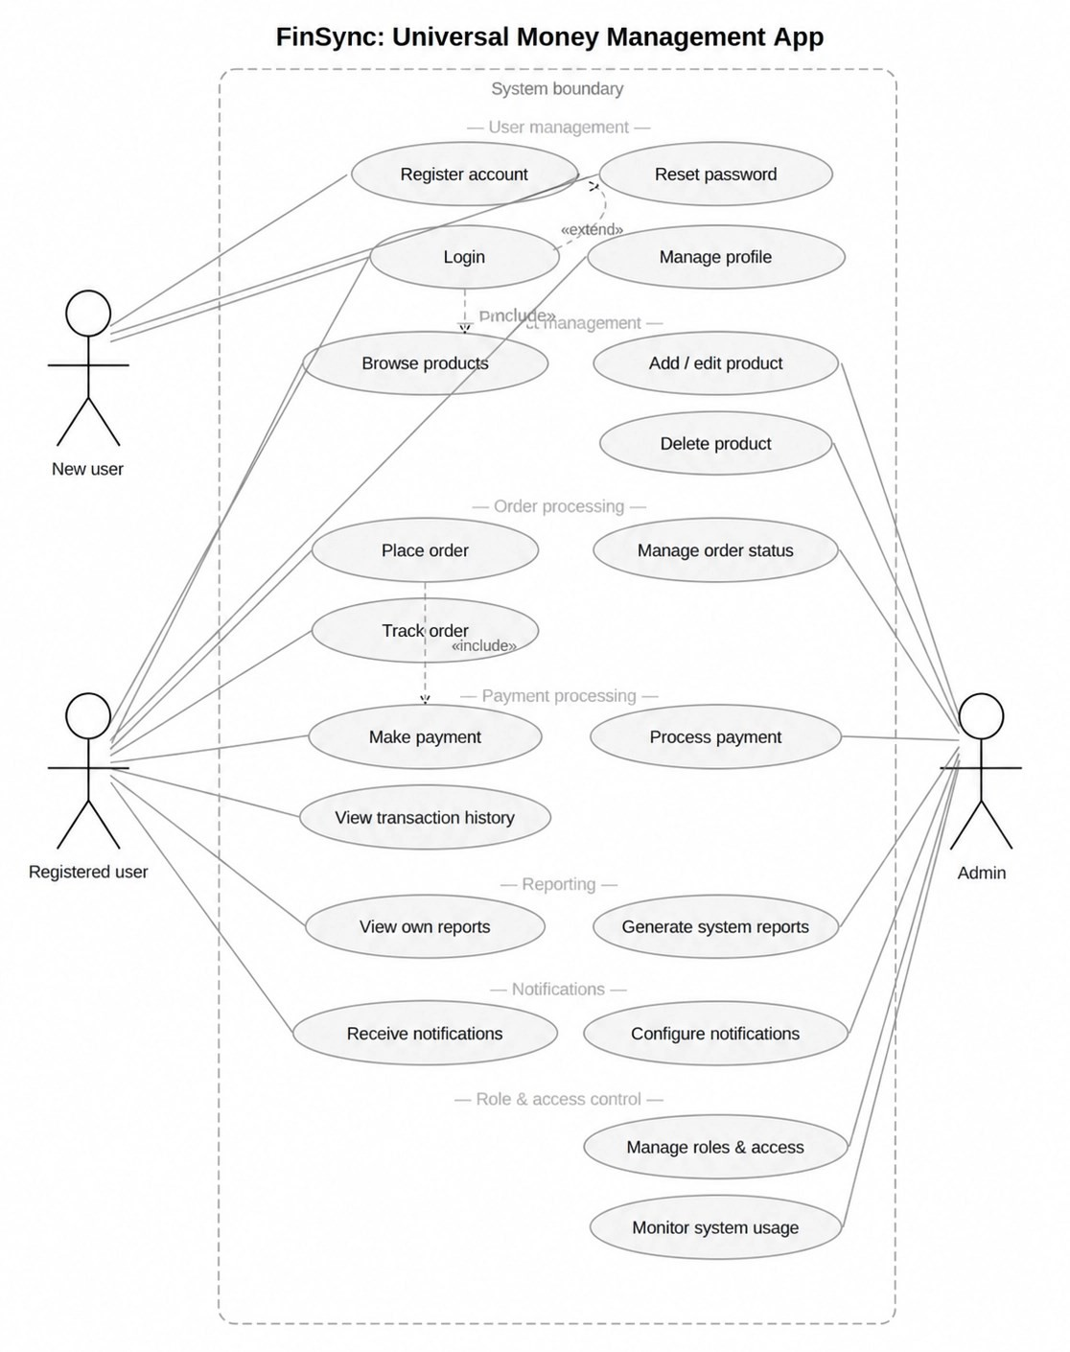

Use Case ID | Use Case Name | Primary Actor | Description | Mapped User Story ID | User Story
UC-01 | Register account | New user | Allows a new user to create an account within the system. | US-01 | As a user, I want to log in using my fingerprint so that I can access my data quickly and securely.
UC-02 | Login | New user, Registered user, Admin | Allows users to authenticate and gain access to the system. | US-01 | As a user, I want to log in using my fingerprint so that I can access my data quickly  and securely.
UC-03 | Reset password | New user, Registered user, Admin | Enables users to reset their forgotten password. | US-01 | As a user, I want to log in using my fingerprint so that I can access my data quickly  and securely.
UC-04 | Manage profile | Registered user, Admin | Allows users to update their personal information and settings. | US-01 | As a user, I want to log in using my fingerprint so that I can access my data quickly and securely.
UC-05 | Browse products | New user, Registered user | Allows users to view available products or services (e.g., financial accounts, categories). | US-04 | As a user, I want an interactive dashboard so that I can see my consolidated balances at a  glance.
UC-06 | Add / edit product | Admin | Enables administrators to add new products or modify existing ones (e.g., managing categories, financial institutions). | US-07 | As a user, I want to create custom spending categories so that I can organize my finances according to  my needs.
UC-07 | Delete product | Admin | Allows administrators  to remove | US-07 | As a user, I want to  create

 |  |  | products from the system (e.g., removing categories, financial institutions). |  | custom spending categories so that I can organize my finances  according to my needs.
UC-08 | Place order | Registered user | Enables registered users to place orders for products or services (e.g., setting up a new budget, recurring expense). | US-09 | As a user, I want to track recurring expenses (e.g., subscriptions, rent) so that I can anticipate upcoming  payments.
UC-09 | Track order | Registered user | Allows registered users to monitor the status of their placed orders (e.g., tracking budget progress, recurring expense  status). | US-09 | As a user, I want to track recurring expenses (e.g., subscriptions, rent) so that I can anticipate upcoming payments.
UC-10 | Make payment | Registered user | Facilitates registered users to make payments for their orders (e.g., marking a recurring expense as paid). | US-09 | As a user, I want to track recurring expenses (e.g., subscriptions, rent) so that I can anticipate upcoming  payments.
UC-11 | Process payment | Admin | Enables administrators to process and confirm user payments (e.g., managing system-level financial data). | US-06 | As a user, I want to manually add cash transactions so that all my spending is recorded.
UC-12 | View transaction history | Registered user | Allows registered users to view their past transaction records. | US-04 | As a user, I want an interactive dashboard so that I can see my  consolidated

balances at a
glance.
UC-13 | View own reports | Registered user | Enables registered users to access personalized financial reports. | US-08 | As a user, I want to receive weekly spending reports so that I can review my financial activity regularly.
UC-14 | Generate system reports | Admin | Allows administrators to generate comprehensive system-wide reports (e.g., overall app usage, financial trends). | US-08 | As a user, I want to receive weekly spending reports so that I can review my financial  activity regularly.
UC-15 | Receive notifications | Registered user | Enables registered users to receive various system notifications (e.g., transaction alerts, budget warnings). | US-09 | As a user, I want to track recurring expenses (e.g., subscriptions, rent) so that I can anticipate upcoming  payments.
UC-16 | Configure notifications | Registered user | Allows registered users to customize their notification settings. | US-09 | As a user, I want to track recurring expenses (e.g., subscriptions, rent) so that I can anticipate upcoming  payments.
UC-17 | Manage roles & access | Admin | Enables administrators to manage user roles and access permissions within the  system. | US-01 | As a user, I want to log in using my fingerprint so that I can access my data quickly  and securely.

Non-functional Requirements
Non-functional requirements specify criteria that can be used to judge the operation of a system, rather than specific behaviors. They are crucial for ensuring the quality and effectiveness of the FinSync application.

Reliability
The FinSync system shall demonstrate high availability and fault tolerance to ensure continuous service for users. The backend services shall maintain an uptime of 99.9% annually, excluding scheduled maintenance windows, to guarantee consistent access to financial data and functionalities. Regular, automated data backups shall be performed daily to a geographically redundant storage solution, ensuring minimal data loss in the event of a catastrophic system failure. Furthermore, the system should implement robust error handling and logging mechanisms to facilitate rapid identification and resolution of operational issues, thereby minimizing service disruptions.

Performance
The system should deliver responsive and efficient user experience. The primary application dashboard, displaying consolidated financial summaries, shall load completely within 2 seconds under typical network conditions (e.g., 4G mobile data connection). Critical operations, such as the parsing and categorization of incoming SMS and WhatsApp transaction alerts, shall be processed and reflected in the user interface within 5 seconds of receipt. This ensures real-time financial updates and maintains user engagement. Database queries for retrieving transaction history or generating reports shall execute within 3 seconds for datasets up to 10,000 transactions.

Use-ability
The FinSync application shall provide an intuitive and accessible user interface. The UI design shall strictly adhere to established Material Design Guidelines for Android and Human Interface Guidelines for iOS, ensuring a consistent and familiar experience across platforms. User workflows, such as adding manual transactions or setting up budgets, should be streamlined, requiring no more than three steps for common tasks. The application shall support a 'Dark Mode' theme, allowing users to switch between light and dark visual styles for enhanced readability and reduced eye strain in varying lighting conditions. All textual content within the application shall be clear, concise, and easily understandable by users with diverse financial literacy levels.

Other Non-functional Requirements
Security is paramount for a financial management application. All sensitive user data, including transaction details and personal identifiable information, shall be encrypted both at rest and in transit. For data at rest, AES-256 encryption shall be utilized, while data in transit shall be secured using Transport Layer Security (TLS) 1.2 or higher. User authentication mechanisms shall include multi-factor authentication (MFA) options, such as biometric verification (fingerprint/face ID) and one-time passwords (OTP) via SMS or email. Regular security audits and penetration testing shall be conducted quarterly to identify and mitigate potential vulnerability, ensuring compliance with industry best practices for financial data protection.

Scrum Activities Plan
The execution of Scrum activities for the FinSync development lifecycle will be strictly anchored around a structured, team-aligned cadence, spanning the entire one-year project duration.
- Daily Scrum Plan: The team will conduct a highly focused, 15-minute sync-up held every working day at 11:00 AM over Slack or in person. During this meeting, Muhammad Hassan (Scrum Master), Abdul Kareem Butt, and Muhammad Faizan will answer the three core Agile questions to review yesterday's individual progress, map out today's development objectives, and immediately flag any technical blocks (such as structural format shifts in raw banking SMS strings or device layout friction).

- Sprint Review Process: At the conclusion of our 4-week sprint iterations, a formal evaluation session will take place on the final Friday at 3:00 PM. The engineering trio will present a live, working software demonstration of the application's current build (such as functional client-side text scraping, OCR invoice scanning, or real-time UI balance updates) directly to the Product Owner, Prof. Mr. Sajid Saleem. This presentation serves to validate completed features against their predefined Acceptance Criteria and absorb direct supervisory feedback back into the prioritized product backlog.

- Sprint Retrospective Plan: Immediately following the review, the team will transition into a private, 30-minute session to openly inspect internal operational workflows. The team will categorize observations into what went well and what encountered friction (e.g., code branch optimization hurdles or machine learning classification memory footprints on the mobile device), ultimately formulate exactly one or two concrete action-item improvements to systematically enhance engineering velocity and collaboration in the subsequent sprint.

Kanban Board / Task Tracking
The Kanban board provides a visual representation of the project's workflow, allowing the team to track tasks from the product backlog through completion. It enhances transparency and helps manage work in progress. Given that the project is currently in the documentation phase, the 'To Do' column lists all features, while 'In Progress' reflects initial development efforts for the upcoming implementation phase. 'Testing' and 'Done' are currently empty as no features have reached these stages yet.

To Do (Product Backlog Items) | In Progress (Current Sprint) | Testing | Done
PB-01: Implement secure login with biometric authentication. | PB-02: Develop NLP models for parsing SMS from major Pakistani  banks.
PB-03: Create an AI-based expense categorization  engine. | PB-06: Allow users to manually add, edit, and delete  cash transactions.

PB-04: Design an interactive dashboard for consolidated
balances.
PB-05: Implement receipt scanning and data extraction
using EasyOCR.
PB-07: Provide functionality to create and manage custom budgeting
categories.
PB-08: Generate automated weekly and monthly
spending reports.
PB-09: Set up tracking for recurring expenses (e.g., subscriptions,
rent).
PB-10: Develop a feature for splitting bills among contacts and tracking who owes
what.

Acceptance Criteria
Acceptance criteria define the conditions that a user story must satisfy to be considered complete. They are testable statements that ensure the functionality meets the user's needs. For each user story, specific test scenarios and expected results will be defined to verify correct functionality, quality, and adherence to user requirements.

Story ID | User Story  (Short) | Test Scenario | Expected Result
US-01 | Biometric Login | User attempts login with registered fingerprint. | System authenticates user via fingerprint; if failed, prompts for  PIN.
US-02 | SMS Parsing | System receives a  transaction SMS | System  automatically

 |  | from a major Pakistani bank (e.g., HBL, UBL,  Meezan). | parses SMS, extracts transaction amount, merchant, and date/time, and displays it in the  app.
US-03 | AI Categorization | A new transaction is added (via SMS or manual entry). | AI engine automatically assigns a category (e.g., 'Food', 'Transport', 'Utilities') to the transaction with  >85% accuracy.
US-04 | Dashboard Design | User opens the FinSync app dashboard. | Dashboard loads within 2 seconds and displays consolidated balances from all linked accounts, recent transactions, and a summary of  spending.
US-05 | OCR Receipt Scanning | User uploads an image of a physical receipt. | OCR module extracts total amount, date, and merchant from the receipt image and suggests a  category.
US-06 | Manual Transaction | User adds a new cash transaction manually. | User can input amount, date, category, and description; transaction is saved and reflected  in balances.
US-07 | Custom Categories | User navigates to settings and creates a new custom category. | User can add, edit, and delete custom spending categories; new categories appear in categorization  options.

US-08 | Weekly Reports | End of the week arrives. | System automatically generates a weekly spending report summarizing expenses by category and sends  it to the user.
US-09 | Recurring Expenses | User defines a new recurring expense (e.g., monthly rent). | System tracks the recurring expense, notifies the user before the due date, and marks it as paid upon  confirmation.
US-10 | Bill Splitting | User initiates a bill split with contacts for a shared expense. | User can select contacts, enter total amount, and system calculates individual shares; notifications sent to participants.

Release Criteria
Release criteria are the conditions that must be met before the software can be released to users. For the FinSync project, these include:
    - Functional Completeness: All high-priority functional requirements and associated user stories for the current release increment must be fully implemented and verified against their acceptance criteria. There should be no known critical or major defects in the core functionalities.
    - Quality and Performance: The application must pass all defined quality gates, including successful execution of automated test suites (unit, integration, and end-to-end tests) with a minimum code coverage of 80%. Performance benchmarks, such as dashboard load times and transaction processing speeds, must meet the non-functional requirements specified in Section 4.2.
    - Security and Reliability: A comprehensive security audit and penetration testing must be successfully completed with all critical vulnerabilities addressed. The system must demonstrate adherence to the reliability targets (e.g., 99.9% uptime) and data integrity measures, including successful daily backups, as outlined in Section 4.1 and 4.4.

    - User Documentation and Training: All necessary user documentation, including user manuals, FAQs, and onboarding guides, must be finalized and made accessible. Any training materials required for support staff or key stakeholders must also be prepared.

Burndown Chart & Progress Tracking
Burndown Chart: A burndown chart visually represents the remaining work in a sprint against time. It helps the team track progress and predict whether the sprint goal will be achieved.

Work Tracking Method: The team will track remaining work in story points. At the beginning of each sprint, the total story points for committed user stories will be plotted. Daily, the team will update the remaining story points based on completed tasks. This provides a clear, real-time view of progress against the sprint goal.

Expected Burn Rate: The expected burn rate will be calculated by dividing the total story points for the sprint by the number of working days. This establishes an ideal burndown line, against which the actual burndown can be compared to identify deviations and adjust sprint activities as needed.

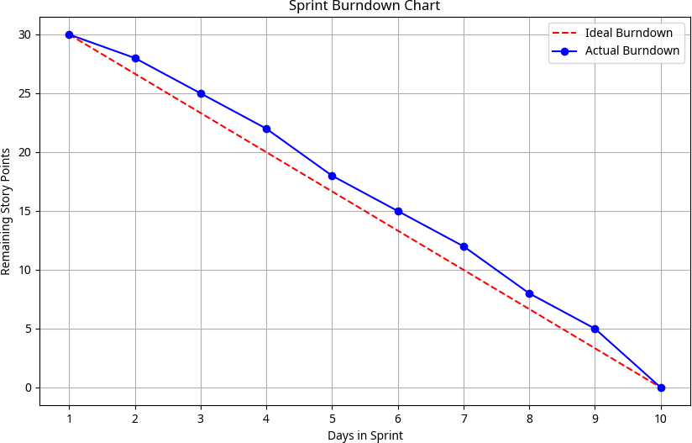

Backlog Refinement Plan
Frequency and Process: The team will conduct a dedicated Backlog Refinement session once every two weeks, typically on Wednesday afternoons, lasting approximately 1 to 2 hours. During these sessions, the Product Owner, Scrum Master, and Development Team will collaborate to review upcoming Product Backlog Items (PBIs). The process involves clarifying requirements, breaking down larger PBIs into smaller, more manageable user stories, adding detail, estimates, and re-prioritizing items based on new information or changing business needs. This continuous process ensures that the Product Backlog remains groomed, well-understood, and ready for future sprint planning, minimizing ambiguity and maximizing efficiency.

Risk Analysis
Risk analysis identifies potential problems that could affect the project and outlines strategies to mitigate them. Proactive risk management is crucial for ensuring project success and minimizing disruptions.

Data Privacy Breach

This risk involves unauthorized access to sensitive user financial data, leading to privacy violations and potential legal repercussions. Mitigation strategies include implementing end-to-end encryption for all data at rest and in transit, conducting regular security audits, and adhering to data protection regulations.

SMS Format Changes

Banks or financial institutions may alter their SMS transaction notification formats, which could disrupt the application's automatic parsing capabilities. To mitigate this, the system will employ flexible NLP models capable of adapting to minor variations and will require continuous monitoring and updates to parsing logic based on real-time data analysis.

API Limitations

Reliance on external APIs for certain functionalities might be limited or subject to change, impacting the system's capabilities. The primary mitigation strategy is to focus on SMS/WhatsApp parsing as the core data aggregation method, reducing dependency on external bank APIs, and exploring alternative data sources or manual input options where APIs are unavailable or unreliable.

AI Model Accuracy

The accuracy of AI models for expense categorization and predictive insights might not meet desired levels, leading to incorrect classifications or less effective financial advice. Mitigation involves continuous training and fine-tuning of AI models with diverse and expanding datasets, implementing user feedback mechanisms for correction, and regularly evaluating model performance against benchmarks.

User Adoption

The risk that users may not adopt the FinSync application due to a steep learning curve, lack of perceived value, or competition. Mitigation focuses on developing an intuitive UI/UX, providing comprehensive onboarding tutorials, and implementing effective marketing and user engagement strategies to highlight the app's unique benefits.

Team Member Availability

The project's progress could be hampered by the unavailability of key team members due to illness, personal emergencies, or other commitments. Mitigation strategies include cross-training of team members to ensure knowledge redundancy, maintaining clear and comprehensive documentation, and establishing communication protocols for urgent situations to minimize single points of failure.

References

- D. Guru and S. R. Subramaniam, "Personalized Real-Time Financial Expense Categorization AI Using OCR and Retrieval-Augmented Generation," in Southeast on 2026, 2026. Available: https://ieeexplore.ieee.org/abstract/document/11476659/
- R. Kumar, K. S. Rohit, and R. Preethi, "FINWISE: Design of Personal Finance Management Application using AI," in *2025 Modern Electronics…*, 2025. Available: https://ieeexplore.ieee.org/abstract/document/11405028/
- M. Islam, "Efficient smart OCR solution for banking document digitization," 2025. Available: https://dspace.bracu.ac.bd/xmlui/handle/10361/27444
- "Automating Financial Management: An Exploration of Automatic Expense Tracking Systems," 2024. Available: https://ieeexplore.ieee.org/abstract/document/10984502/
- "Security in next generation mobile payment systems: A comprehensive survey," 2021.
Available: https://ieeexplore.ieee.org/document/9514868/
- "AI-Driven Personal Finance Assistant with Voice, OCR, and Chatbot," IJERT, vol. 15, no. 04,
pp. 439, Apr. 2026. Available: https://www.ijert.org/ai-driven-personal-finance-assistant-with-voice-ocr-and-chatbot-ijertv15is040439
- "Expense Tracker App with OCR & ML," *Scribd*, Nov. 7, 2025. Available: https://www.scribd.com/document/945048108/Expense-Tracker-An-Expense-Tracking-Application
- "OCR in Finance: A Web-Based Approach for Personalized Expense…," IJARSCT. Available: https://www.ijarsct.co.in/Paper26438.pdf
- "Advanced Personal Budget Analytics: Combining Optical Character Recognition and Natural Language Processing for Automated Budget Categorization and Insight Extraction," ResearchGate, Oct. 10, 2024. Available: https://www.researchgate.net/publication/384963873_Advanced_Personal_Budget_Analytics_Co mbining_Optical_Character_Recognition_and_Natural_Language_Processing_for_Automated_Bu dget_Categorization_and_Insight_Extraction
- "WELTH - AI FINANCE PLATFORM," TechRxiv, Jun. 5, 2025. Available:
https://www.techrxiv.org/doi/pdf/10.36227/techrxiv.174909847.74844950
- "AI Powered Personal Finance Tracker," TIJER. Available: https://tijer.org/tijer/papers/TIJER2604076.pdf
- "Expense Tracker," IRE Journals. Available: https://www.irejournals.com/formatedpaper/1711868.pdf
- "Research Paper: Expenzo – The Smart Finance Tracker," IJARIIT, Dec. 19, 2025. Available: https://www.ijariit.com/manuscript/expenzo-the-smart-finance-tracker/

Appendix A: Glossary
  - Acceptance Criteria (AC): A set of predefined requirements that must be met for a user story to be considered complete.
  - Agile: An iterative and incremental approach to software development that emphasizes collaboration, flexibility, and customer feedback.
  - AI (Artificial Intelligence): The simulation of human intelligence processes by machines, especially computer systems.
  - API (Application Programming Interface): A set of definitions and protocols for building and integrating application software.
  - Backlog Refinement: The ongoing process of adding detail, estimates, and order to items in the Product Backlog.
  - Burndown Chart: A graphical representation of work left to do versus time, used to track progress within a sprint.
  - Kanban: A visual system for managing work as it moves through a process, emphasizing continuous delivery and minimizing work-in-progress.
  - ML (Machine Learning): A subset of AI that enables systems to learn from data without being explicitly programmed.
  - NLP (Natural Language Processing): A field of AI that focuses on enabling computers to understand, interpret, and generate human language.
  - Non-functional Requirements (NFRs): Criteria used to judge the operation of a system, rather than specific behaviors (e.g., performance, security, usability).
  - OCR (Optical Character Recognition): The electronic or mechanical conversion of images of typed, handwritten or printed text into machine-encoded text.
  - Product Backlog (PB): An ordered list of everything that might be needed in the product.
  - Scrum: An agile framework for managing complex projects, emphasizing iterative and incremental work sprints.
  - Sprint: A fixed-length iteration (typically 2-4 weeks) during which a cross-functional team works to complete a set of product backlog items.
  - Story Point: A unit of measure for expressing the overall effort required to implement a user story or product backlog item.
  - User Story (US): A short, simple description of a feature told from the perspective of the person who desires the new capability, usually a user or customer of the system.
  - Use Case Diagram: A graphical representation of a system's functionality, showing how users interact with the system to achieve specific goals.
  - FYP (Final Year Project): An academic project undertaken by students in their final year of study.
  - UI/UX (User Interface/User Experience): UI refers to the visual elements of an application, while UX focuses on the overall experience of using the product.
  - SRS (Software Requirements Specification): A document that describes the intended purpose, features, and constraints of a software system.

Appendix B: IV & V Report

(Independent verification & validation) IV & V Resource

Name Signature

S# | Defect Description | Origin Stage | Status | Fix Time
 |  |  |  | Hours | Minutes
1
2
3
…

Table 1: List of non-trivial defects

FinSync


University of Central Punjab
(Incorporated by Ordinance No. XXIV of 2002 promulgated by Government of the Punjab)

Faculty of Information Technology and Computer Science
Semester wise SDP Meeting Report
Group ID | Student Roll Number | Student Name and Signatures | Advisor
S26CS033 | L1S22BSCS0005 | Muhammad Hassan
 | L1S23BSCS0126 | Abdul Kareem Butt
 | L1S23BSCS0191 | Muhammad Faizan

Sr. | Date | Status (P/A/L) |  |  | Agenda Items | Notes
 |  | Student 1 | Student 2 | Student 3
1 | 26-02-26 | P | P | P | Discussion about Projects Initial Architecture | Defined system boundaries and data flow pipeline. Finalized frontend-backend communication model.
2 | 11-03-26 | P | P | P | Tech Stack selection | Finalized Flutter for cross-platform frontend, Python for backend AI integration, and SQL for relational database management.
3 | 16-04-26 | P | P | P | Development Environment Setup | Initialized Git repository, configured local backend/frontend environments.
4 | 15-05-26 | P | P | P | Phase 1 SRS Documentation | Finalized functional and non-functional requirements. Prepared draft for review.

Date: 20-05-26 Advisor's Signatures:

